**************************************************************************
Exercise 3
Aim: R code to perform importing data from text file and excel file.
Author: 24251115
Date: 3-4-2025
***************************************************************************
library(xlsx)

setwd("c:/College/R Programming/Lab Records/Lab Record 3")

textData = read.table("LabRecord3.txt", header = TRUE, sep = "\t", fill = TRUE)
excelData = read.xlsx("LabRecord3.xlsx", sheetIndex = 1, header = TRUE)

print(textData)
print(excelData)

Output:
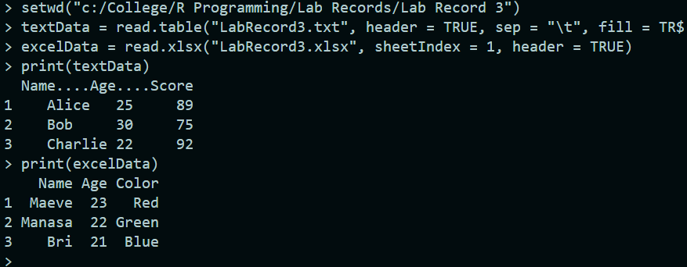

**************************************************************************
Exercise 4
Aim: Implement R program using functions to find the mean, median, standard deviation of vector (do not use built in functions) input the vector elements from the keyboard.
Author: 24251115
Date: 22-4-2025
***************************************************************************
# Function to calculate the mean
calculate_mean <- function(vec) {
sum <- 0
for (val in vec) {
sum <- sum + val
}
return(sum / length(vec))
}

# Function to calculate the median
calculate_median <- function(vec) {
sorted_vec <- sort(vec)
n <- length(sorted_vec)
if (n %% 2 == 0) {
# If even, average the two middle values
return((sorted_vec[n / 2] + sorted_vec[n / 2 + 1]) / 2)
} else {
# If odd, return the middle value
return(sorted_vec[(n + 1) / 2])
}
}

# Function to calculate the standard deviation
calculate_sd <- function(vec) {
mean <- calculate_mean(vec)
sum_sq_diff <- 0
for (val in vec) {
sum_sq_diff <- sum_sq_diff + (val - mean)^2
}
variance <- sum_sq_diff / (length(vec) - 1) # Sample standard deviation
return(sqrt(variance))
}

# Input vector elements from the keyboard
cat("Enter the vector elements separated by spaces: ")
input <- scan(what = numeric())

# Calculate and display the results
cat("Mean:", calculate_mean(input), "\n")
cat("Median:", calculate_median(input), "\n")
cat("Standard Deviation:", calculate_sd(input), "\n")

Output:
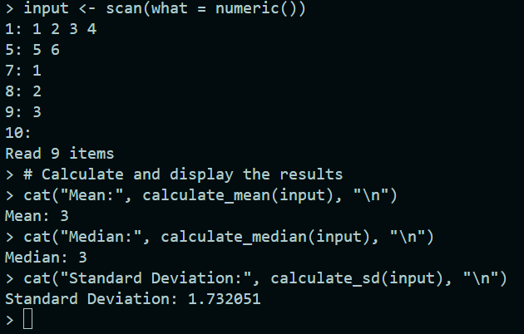
**************************************************************************
Exercise 5
Aim: R code to Import the data from text file and visualize using data using any 5 plots
Author: 24251115
Date: 22-4-2025
***************************************************************************
# Set the working directory
setwd("c:/College/R Programming/Lab Records/Lab Record 5")

# Step 1: Write data to a text file
data <- data.frame(
Name = c("Maeve", "Manasa", "Gavin", "Bri", "Anu", "Rashmita", "Carol"),
Color = c("Red", "Green", "Black", "Blue", "Blue", "Green", "Red"),
Age = c(25, 30, 22, 28, 24, 29, 26)
)
write.table(data, "LabRecord5.txt", sep = "\t", row.names = FALSE, quote = FALSE)

# Step 2: Import data from the text file
data <- read.table("LabRecord5.txt", header = TRUE, sep = "\t", stringsAsFactors = FALSE)

# Print the imported data and column names for debugging
print(data)
print(colnames(data))

# Load ggplot2 for visualization
library(ggplot2)

# Step 3: Visualize the data

# 1. Bar Plot: Count of Colors
ggplot(data, aes(x = Color, fill = Color)) +
geom_bar() +
labs(title = "Bar Plot of Colors", x = "Color", y = "Count") +
theme_minimal()

# 2. Pie Chart: Proportion of Colors
color_counts <- as.data.frame(table(data$Color))
ggplot(color_counts, aes(x = "", y = Freq, fill = Var1)) +
geom_bar(stat = "identity", width = 1) +
coord_polar("y") +
labs(title = "Pie Chart of Colors", fill = "Color")

# 3. Histogram: Age Distribution
ggplot(data, aes(x = Age)) +
geom_histogram(binwidth = 2, fill = "skyblue", color = "black") +
labs(title = "Histogram of Age Distribution", x = "Age", y = "Frequency")

# 4. Scatter Plot: Age vs Index
data$Index <- 1:nrow(data) # Add an index column
ggplot(data, aes(x = Index, y = Age, color = Color)) +
geom_point(size = 3) +
labs(title = "Scatter Plot of Age by Index", x = "Index", y = "Age")

# 5. Boxplot: Age Distribution by Color
ggplot(data, aes(x = Color, y = Age, fill = Color)) +
geom_boxplot() +
labs(title = "Boxplot of Age by Color", x = "Color", y = "Age")

Output:
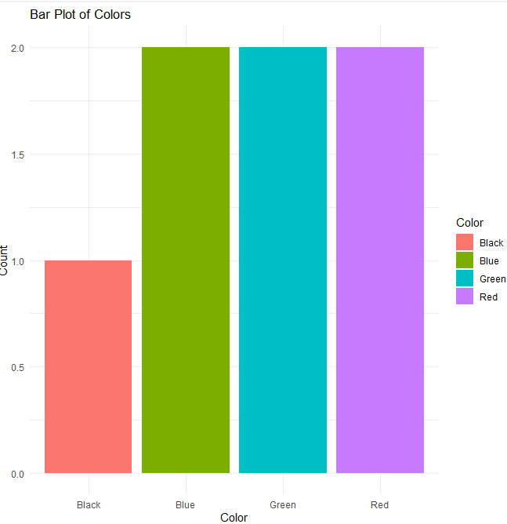
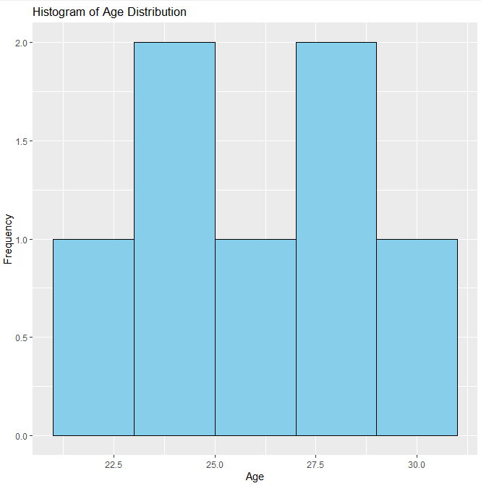
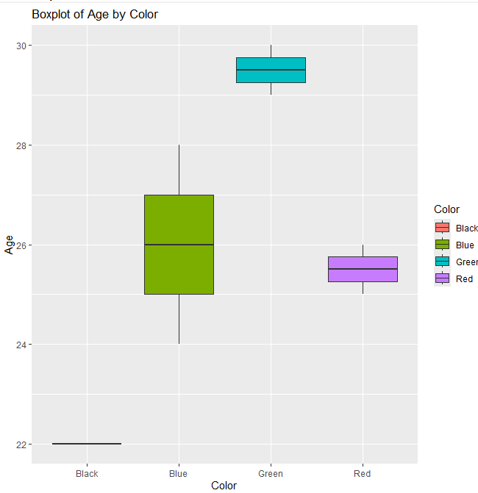
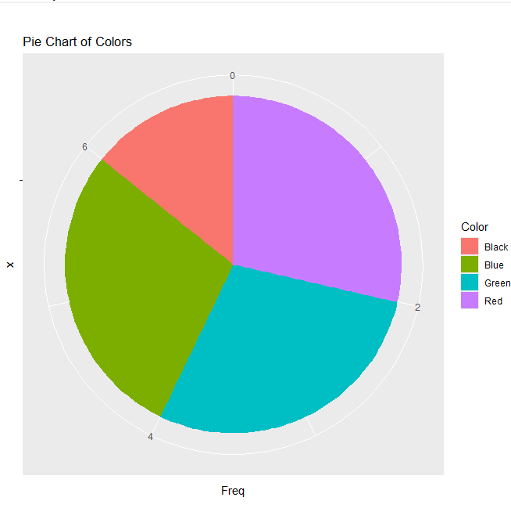
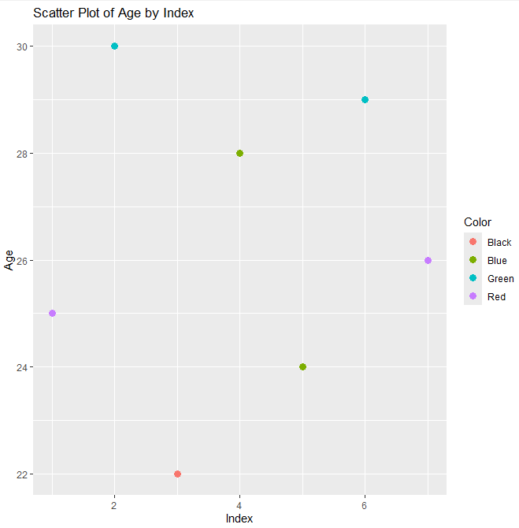

**************************************************************************
Exercise 6
Aim: Write an R program that demonstrates the use of cumulative functions.

Author: 24251115
Date: 22-4-2025
***************************************************************************
require(dplyr)

# Sample vector
vec <- c(2, 4, 6, 8, 10)

# Cumulative sum
cat("Cumulative Sum:\n")
print(cumsum(vec))

# Cumulative product
cat("Cumulative Product:\n")
print(cumprod(vec))

# Cumulative maximum
cat("Cumulative Maximum:\n")
print(cummax(vec))

# Cumulative minimum
cat("Cumulative Minimum:\n")
print(cummin(vec))

# Example with logical cumulative function
logical_vec <- c(TRUE, FALSE, TRUE, TRUE, FALSE)
cat("Cumulative Logical OR:\n")
print(cumany(logical_vec))

cat("Cumulative Logical AND:\n")
print(cumall(logical_vec))

Output:
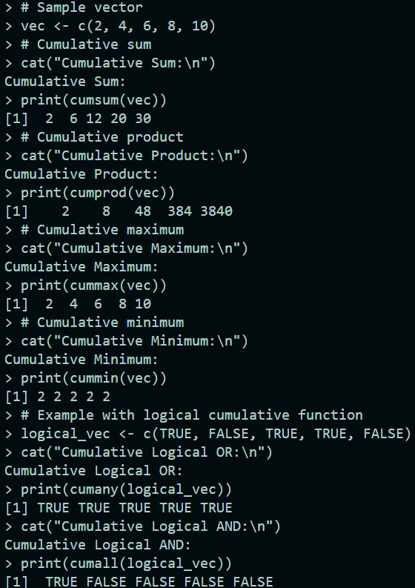

**************************************************************************
Exercise 12
Aim: Apply naïve bayes classifier on a given data set(2 columns)

Outlook | Play
Rainy | Yes
Sunny | Yes
Overcast | Yes
Overcast | yes
Sunny | No
Rainy | yes
Sunny | Yes
Overcast | yes
Rainy | No
Sunny | No
Sunny | Yes
Rainy | No
Overcast | Yes
Sunny | Yes
Sunny | ?

Author: 24251115
Date: 03-5-2025
***************************************************************************
Data Set:
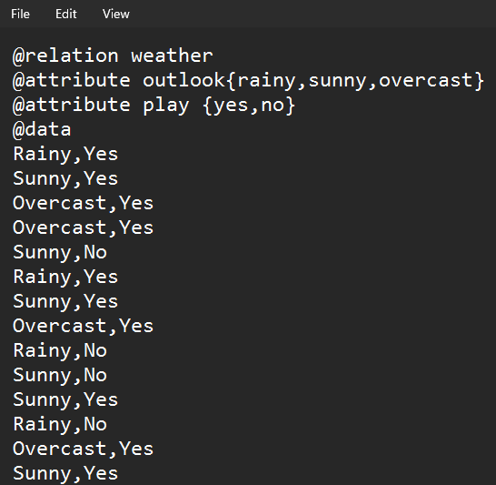
Open the data set file:
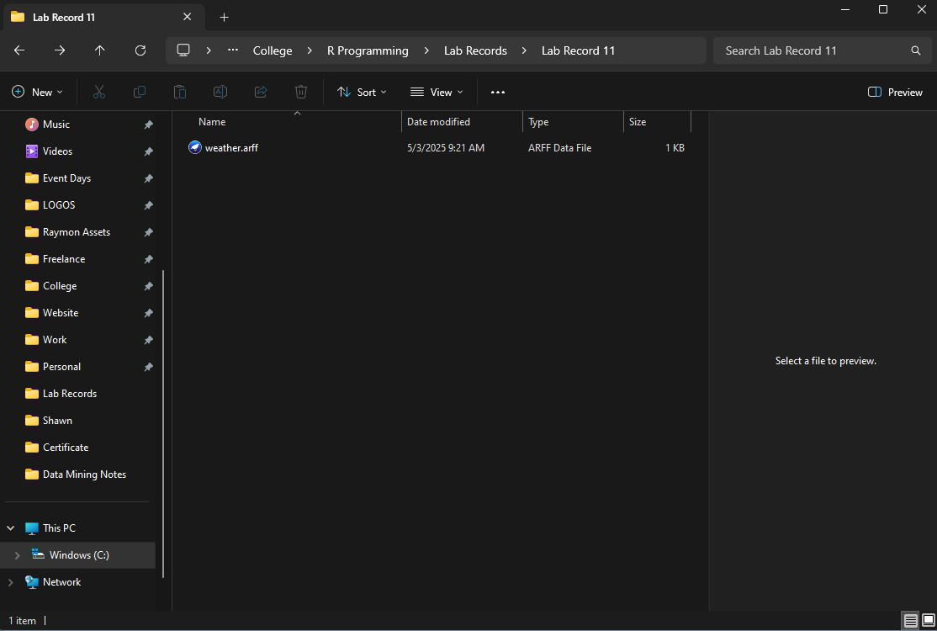

Pre – Processing:
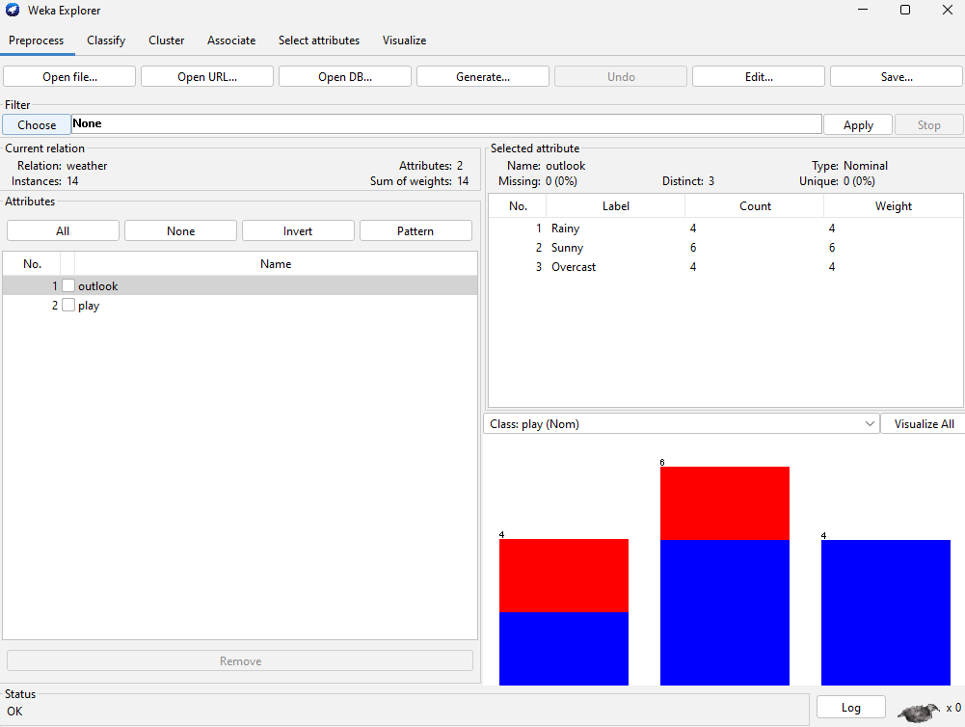
Classifier in naïve bayes:
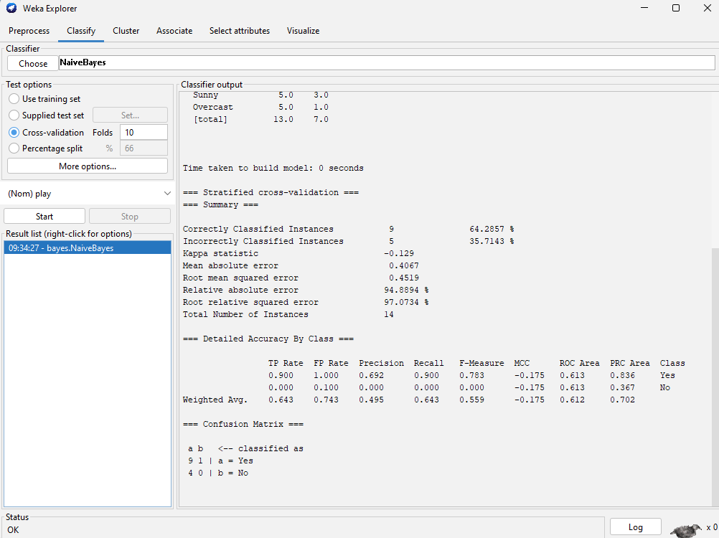

Create & open the supplied test set:
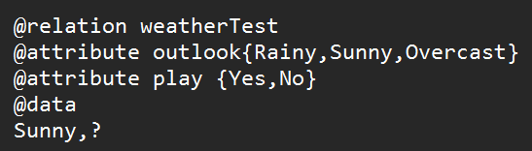

Use the supplied test set:
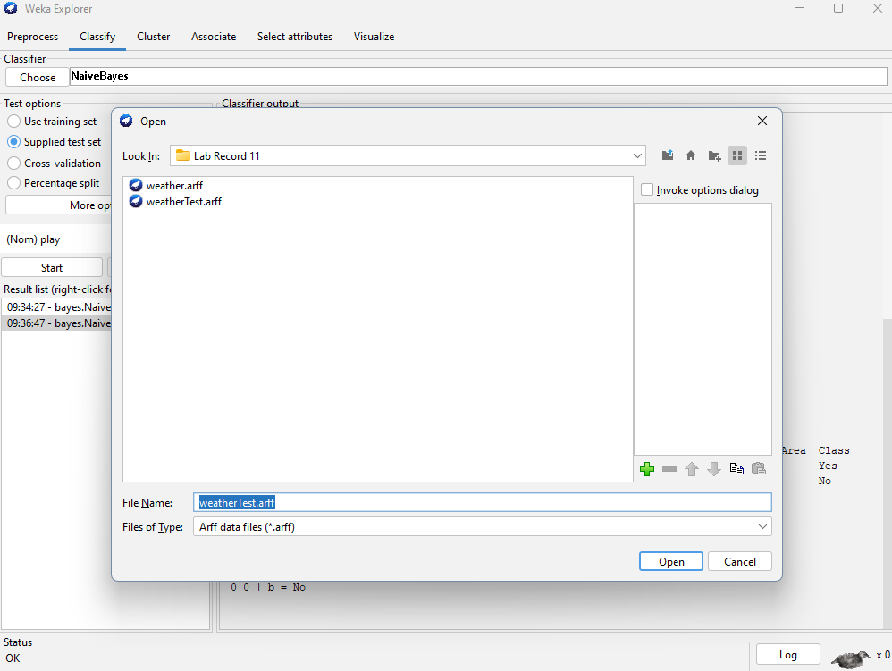

Classifier in naïve bayes:
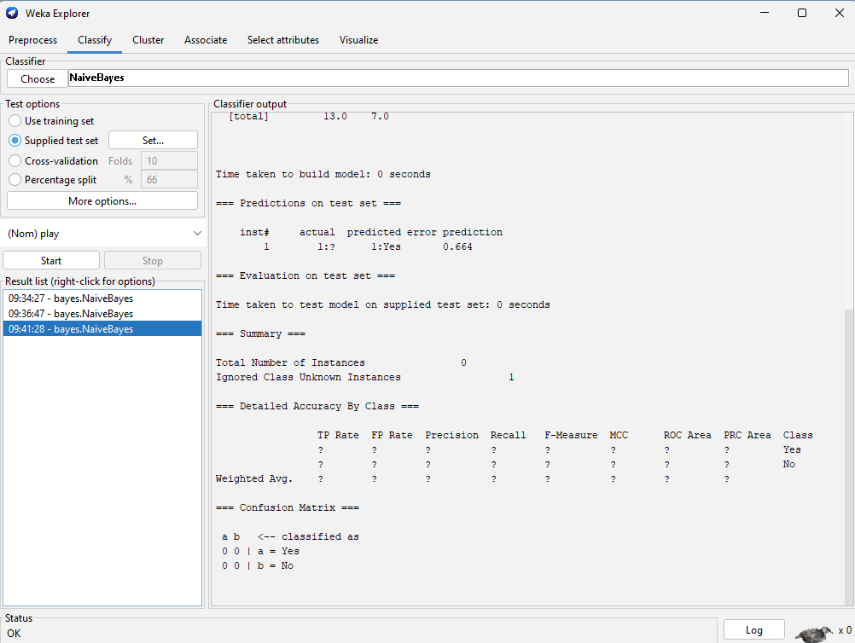
**************************************************************************
Exercise 13
Aim: R code to find Mean, Median, and Mode for the Un-grouped data

Author: 24251115
Date: 03-5-2025
***************************************************************************
# Sample ungrouped data
data <- c(1, 2, 2, 3, 4, 4, 4, 5, 6)

# Calculate the mean using the inbuilt mean() function
mean_value <- mean(data)

# Calculate the median using the inbuilt median() function
median_value <- median(data)

# Calculate the mode using inbuilt functions
calculate_mode <- function(vec) {
freq_table <- table(vec) # Frequency table
max_freq <- max(freq_table) # Maximum frequency
mode_values <- as.numeric(names(freq_table[freq_table == max_freq]))
return(mode_values)
}
mode_value <- calculate_mode(data)

# Display the results
cat("Mean:", mean_value, "\n")
cat("Median:", median_value, "\n")
cat("Mode:", mode_value, "\n")

Output:
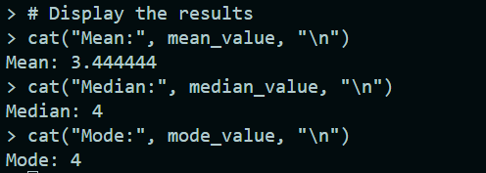

**************************************************************************
Exercise 14
Aim: R code to find Mean, Median, and Mode for the Grouped data

Author: 24251115
Date: 03-5-2025
***************************************************************************
# Class intervals and frequencies
lower <- c(0, 10, 20, 30, 40)
upper <- c(10, 20, 30, 40, 50)
freq <- c(5, 8, 15, 10, 2)

# Midpoints
mid <- (lower + upper) / 2

# Total frequency
N <- sum(freq)

# Mean
mean_val <- sum(mid * freq) / N

# Cumulative frequency
cum_freq <- cumsum(freq)

# Median
med_class <- which(cum_freq >= N / 2)[1]
L <- lower[med_class]
F <- ifelse(med_class == 1, 0, cum_freq[med_class - 1])
f <- freq[med_class]
h <- upper[med_class] - lower[med_class]
median_val <- L + ((N / 2 - F) / f) * h

# Mode
mod_class <- which.max(freq)
Lm <- lower[mod_class]
f1 <- freq[mod_class]
f0 <- ifelse(mod_class == 1, 0, freq[mod_class - 1])
f2 <- ifelse(mod_class == length(freq), 0, freq[mod_class + 1])
mode_val <- Lm + ((f1 - f0) / ((2 * f1) - f0 - f2)) * h

# Results
cat("Mean:", mean_val, "\n")
cat("Median:", median_val, "\n")
cat("Mode:", mode_val, "\n")

Output:
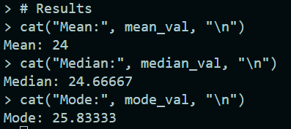

**************************************************************************
Exercise 15
Aim: R code to Calculate lower and upper quartiles, third deciles and 20th percentiles for the following data:

C.I: 0-5 5-10 10-15 15-20 20-25
Frequency 7 18 25 30 20

Author: 24251115
Date: 03-5-2025
***************************************************************************
# Class intervals and frequencies
class_intervals <- c(0, 5, 10, 15, 20, 25) # Class intervals
frequencies <- c(7, 18, 25, 30, 20) # Frequencies

# Calculate cumulative frequencies
cumulative_frequencies <- cumsum(frequencies)

# Total frequency
N <- sum(frequencies)

# Class width
h <- class_intervals[2] - class_intervals[1]

# Function to calculate the value for a given cumulative percentage
calculate_value <- function(cum_percentage) {
position <- N * cum_percentage
class_index <- which(cumulative_frequencies >= position)[1]
L <- class_intervals[class_index] # Lower boundary of the class
F <- ifelse(class_index == 1, 0, cumulative_frequencies[class_index - 1]) # Cumulative frequency before the class
f <- frequencies[class_index] # Frequency of the class
return(L + ((position - F) / f) * h)
}

# Calculate Q1 (lower quartile, 25th percentile)
Q1 <- calculate_value(0.25)

# Calculate Q3 (upper quartile, 75th percentile)
Q3 <- calculate_value(0.75)

# Calculate D3 (third decile, 30th percentile)
D3 <- calculate_value(0.3)

# Calculate P20 (20th percentile)
P20 <- calculate_value(0.2)

# Display the results
cat("Lower Quartile (Q1):", Q1, "\n")
cat("Upper Quartile (Q3):", Q3, "\n")
cat("Third Decile (D3):", D3, "\n")
cat("20th Percentile (P20):", P20, "\n")

Output:
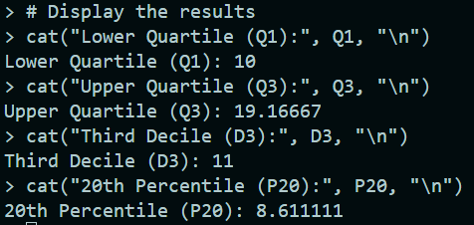

**************************************************************************
Exercise 16
Aim: R code to calculate the regression. Visualize of the data using scatter plot
Author: 24251115
Date: 03-5-2025
***************************************************************************
# Sample data
x <- c(1, 2, 3, 4, 5)
y <- c(2, 4, 5, 4, 5)

# Linear regression
model <- lm(y ~ x)

# Print regression equation
cat("Regression Equation: y =", round(coef(model)[1], 2), "+", round(coef(model)[2], 2), "* x\n")

# Summary of the model (optional)
summary(model)

# Scatter plot with regression line
plot(x, y, main = "Scatter Plot with Regression Line", xlab = "X", ylab = "Y", pch = 19, col = "blue")
abline(model, col = "red", lwd = 2)

Output:
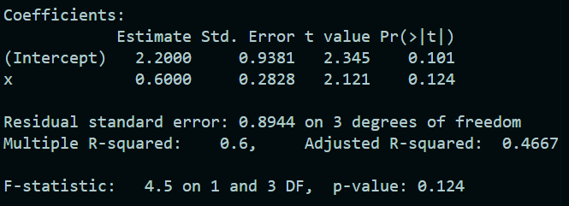

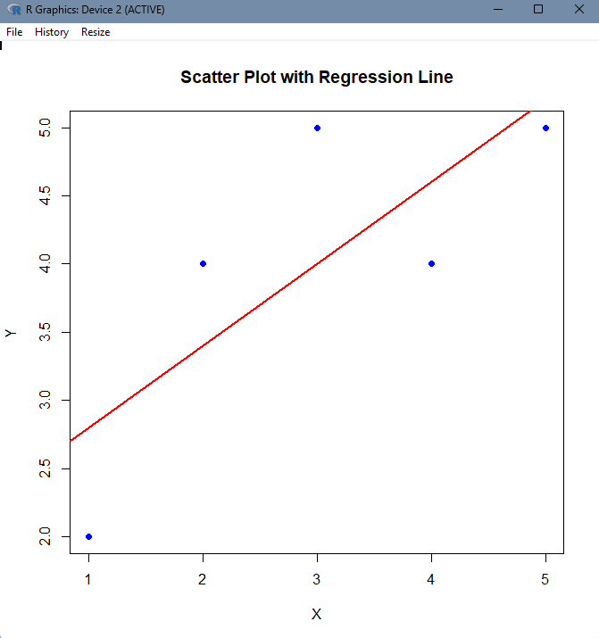
**************************************************************************
Exercise 17
Aim: Suppose that the data for analysis includes the attribute age. The age values for the data tuples are (in increasing order):
13,15,16,19,20,21,22,22,25,25,25,25,30,33,33,35,35,35,35,36,40,45,46,52,70
- Show a boxplot of the data
- Give the five-number summary of the data and visualize using box plot.
- Calculate IQR.
Author: 24251115
Date: 03-5-2025
***************************************************************************
# Data
ages <- c(13,15,16,19,20,21,22,22,25,25,25,25,30,33,33,35,35,35,35,36,40,45,46,52,70)

# a) Boxplot
boxplot(ages, main = "Boxplot of Ages", col = "lightblue")

# b) Five-number summary
summary <- fivenum(ages)
cat("Five-number summary:", summary, "\n")

# c) Interquartile Range (IQR)
iqr <- IQR(ages)
cat("Interquartile Range (IQR):", iqr, "\n")

Output:
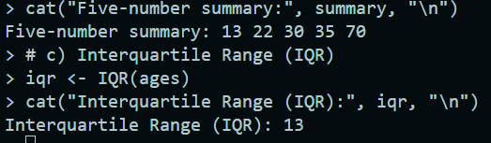
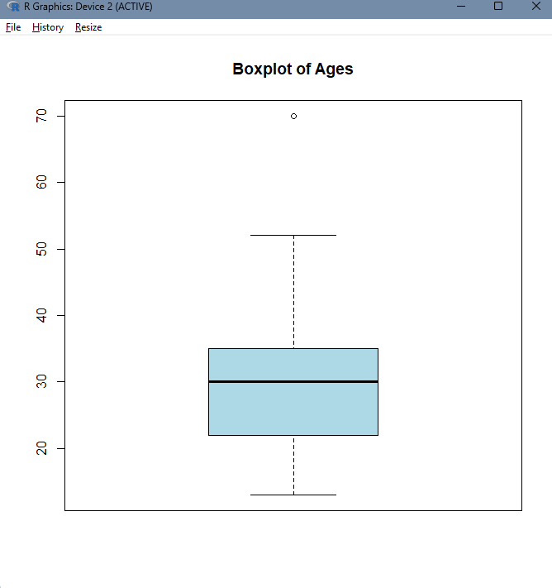

**************************************************************************
Exercise 18
Aim: A movie producer is bringing out a new movie. In order to map out advertising campaign, he wants to determine whether the movie will approx.. most to particular age group or whether it will appeal equlity to all age group. The producer takes a random sample from person attending preview of the new movie obtains the following result.

Year | Under 20 | 20-39 | 40-59 | 60and over | Total
Liked | 146 | 78 | 48 | 98 | 300
Disliked | 54 | 22 | 42 | 92 | 140
Indifferent | 20 | 10 | 10 | 20 | 60
Total | 220 | 110 | 100 | 70 | 500

What reference will you draw from this data(Use Chi- square test)
Author: 24251115
Date: 03-5-2025
***************************************************************************

